56th Annual
Shawano County Art & Craft Fair
Sponsored by: Shawano County Arts Council
Sunday, July 26, 2026
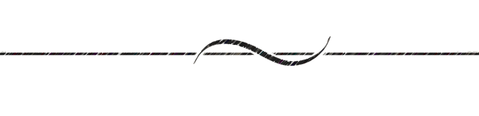
10:00 a.m. to 4:00 p.m.

LOCATION Mielke County Park and Art Center, N5649 Airport Road, Shawano, Wisconsin
Sites are all outside on the grass or among the trees, enjoy the new fountain in pond!
REGISTRATION $40 advance fee is nonrefundable for a 12’x12’ pre-assigned space. Use the registration form below and mail to Shawano County Arts Council. Please include a self addressed stamped envelope for your confirmation. Registration Desk and Set-up opens at 7:00 a.m. No commission is charged.

PARTICIPATION Exhibit and Sale of Arts & Crafts: The exhibitor is responsible to set up by 10:00 a.m. The exhibitor is solely responsible for all loss, theft, or damage to any of his/her property used in the fair. Each exhibitor is responsible for cleaning up of his/her space at the end of the day. EXHIBITORS ARE EXPECTED TO REMAIN OPEN UNTIL 4:00 P.M.

NO KITS, MANUFACTURED, OR RESALE ITEMS permitted. Only original Art and Crafts may be sold .

Please submit a photo of your work {if possible} with application.

AWARDS Ribbon and cash awards will be given for both Arts and Crafts.

DEADLINE Entries accepted February 15-July 20, 2026. Exhibitors registered by July 20 will have their location shown on our map. Confirmation will be within a month of receipt of application.

INFORMATION For questions call/text Patty at 715.851.5761 or email @momrocks7822@yahoo.com.
Please notify us of an address or email change or
if you would like to be taken off our mailing list.

Please enjoy your day at our fair. Ask for help with set-up and take down.

Required Information - PLEASE PRINT CLEARLY

Name

Address City St __ Zip

Email Phone

Media (brief description)

Is the media made by you? Yes No If no, by whom?

List Your Prior Space #(s) Preference (if any) ________________ Location Preference Woods Open Grass

# of Spaces ____ Fee of $40 per space is enclosed for a total of _____.

Make Checks Payable to: Shawano County Arts Council

Mail Registration and Check To: Shawano County Arts Council, P.O. Box 213, Shawano WI 54166-0213

Internal Use Only
Reg. Received |  | Check # |  | Confirmation Sent

